Wireshark Lab: IP v6.0  Supplement to Computer Networking: A Top-Down Approach, 6th ed., J.F. Kurose and K.W. Ross  “Tell me and I forget. Show me and I remember. Involve me and I understand.” Chinese proverb  © 2005-21012, J.F Kurose and K.W. Ross, All Rights Reserved | 

In this lab, we’ll investigate the IP protocol, focusing on the IP datagram. We’ll do so by analyzing a trace of IP datagrams sent and received by an execution of the traceroute program (the traceroute program itself is explored in more detail in the Wireshark ICMP lab). We’ll investigate the various fields in the IP datagram, and study IP fragmentation in detail.

Before beginning this lab, you’ll probably want to review sections 1.4.3 in the text and section 3.4 of RFC 2151 [ftp://ftp.rfc-editor.org/in-notes/rfc2151.txt] to update yourself on the operation of the traceroute program. You’ll also want to read Section 4.4 in the text, and probably also have RFC 791 [ftp://ftp.rfc-editor.org/in-notes/rfc791.txt] on hand as well, for a discussion of the IP protocol.

1. Capturing packets from an execution of traceroute

In order to generate a trace of IP datagrams for this lab, we’ll use the traceroute program to send datagrams of different sizes towards some destination, X. Recall that traceroute operates by first sending one or more datagrams with the time-to-live (TTL) field in the IP header set to 1; it then sends a series of one or more datagrams towards the same destination with a TTL value of 2; it then sends a series of datagrams towards the same destination with a TTL value of 3; and so on. Recall that a router must decrement the TTL in each received datagram by 1 (actually, RFC 791 says that the router must decrement the TTL by at least one). If the TTL reaches 0, the router returns an ICMP message (type 11 – TTL-exceeded) to the sending host. As a result of this behavior, a datagram with a TTL of 1 (sent by the host executing traceroute) will cause the router one hop away from the sender to send an ICMP TTL-exceeded message back to the sender; the datagram sent with a TTL of 2 will cause the router two hops away to send an ICMP message back to the sender; the datagram sent with a TTL of 3 will cause the router three hops away to send an ICMP message back to the sender; and so on. In this manner, the host executing traceroute can learn the identities of the routers between itself and destination X by looking at the source IP addresses in the datagrams containing the ICMP TTL-exceeded messages.

We’ll want to run traceroute and have it send datagrams of various lengths.

- Windows. The tracert program (used for our ICMP Wireshark lab) provided with Windows does not allow one to change the size of the ICMP echo request (ping) message sent by the tracert program. A nicer Windows traceroute program is pingplotter, available both in free version and shareware versions at http://www.pingplotter.com. Download and install pingplotter, and test it out by performing a few traceroutes to your favorite sites. The size of the ICMP echo request message can be explicitly set in pingplotter by selecting the menu item Edit-> Options->Packet Options and then filling in the Packet Size field. The default packet size is 56 bytes. Once pingplotter has sent a series of packets with the increasing TTL values, it restarts the sending process again with a TTL of 1, after waiting Trace Interval amount of time. The value of Trace Interval and the number of intervals can be explicitly set in pingplotter.
- Linux/Unix/MacOS. With the Unix/MacOS traceroute command, the size of the UDP datagram sent towards the destination can be explicitly set by indicating the number of bytes in the datagram; this value is entered in the traceroute command line immediately after the name or address of the destination. For example, to send traceroute datagrams of 2000 bytes towards gaia.cs.umass.edu, the command would be:
%traceroute gaia.cs.umass.edu 2000

Do the following:
- Start up Wireshark and begin packet capture (Capture->Start) and then press OK on the Wireshark Packet Capture Options screen (we’ll not need to select any options here).
- If you are using a Windows platform, start up pingplotter and enter the name of a target destination in the “Address to Trace Window.” Enter 3 in the “# of times to Trace” field, so you don’t gather too much data. Select the menu item Edit->Advanced Options->Packet Options and enter a value of 56 in the Packet Size field and then press OK. Then press the Trace button. You should see a pingplotter window that looks something like this:

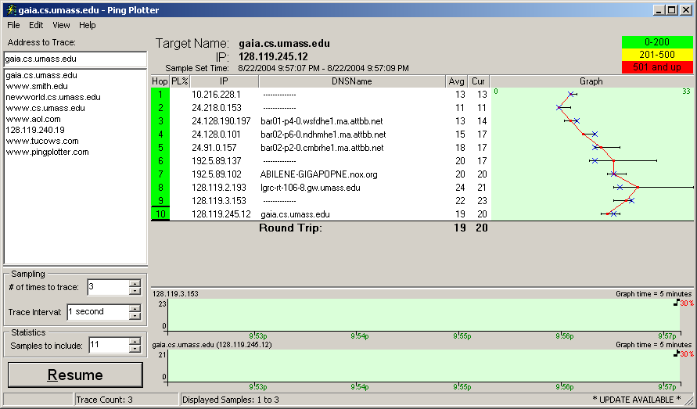

Next, send a set of datagrams with a longer length, by selecting Edit->Advanced Options->Packet Options and enter a value of 2000 in the Packet Size field and then press OK. Then press the Resume button.

Finally, send a set of datagrams with a longer length, by selecting Edit->Advanced Options->Packet Options and enter a value of 3500 in the Packet Size field and then press OK. Then press the Resume button.

Stop Wireshark tracing.

- If you are using a Unix or Mac platform, enter three traceroute commands, one with a length of 56 bytes, one with a length of 2000 bytes, and one with a length of 3500 bytes.

Stop Wireshark tracing.

If you are unable to run Wireshark on a live network connection, you can download a packet trace file that was captured while following the steps above on one of the author’s Windows computers. You may well find it valuable to download this trace even if you’ve captured your own trace and use it, as well as your own trace, when you explore the questions below.

2. A look at the captured trace

In your trace, you should be able to see the series of ICMP Echo Request (in the case of Windows machine) or the UDP segment (in the case of Unix) sent by your computer and the ICMP TTL-exceeded messages returned to your computer by the intermediate routers. In the questions below, we’ll assume you are using a Windows machine; the corresponding questions for the case of a Unix machine should be clear. Whenever possible, when answering a question below you should hand in a printout of the packet(s) within the trace that you used to answer the question asked. When you hand in your assignment, annotate the output so that it’s clear where in the output you’re getting the information for your answer (e.g., for our classes, we ask that students markup paper copies with a pen, or annotate electronic copies with text in a colored font).To print a packet, use File->Print, choose Selected packet only, choose Packet summary line, and select the minimum amount of packet detail that you need to answer the question.

- Select the first ICMP Echo Request message sent by your computer, and expand the Internet Protocol part of the packet in the packet details window.

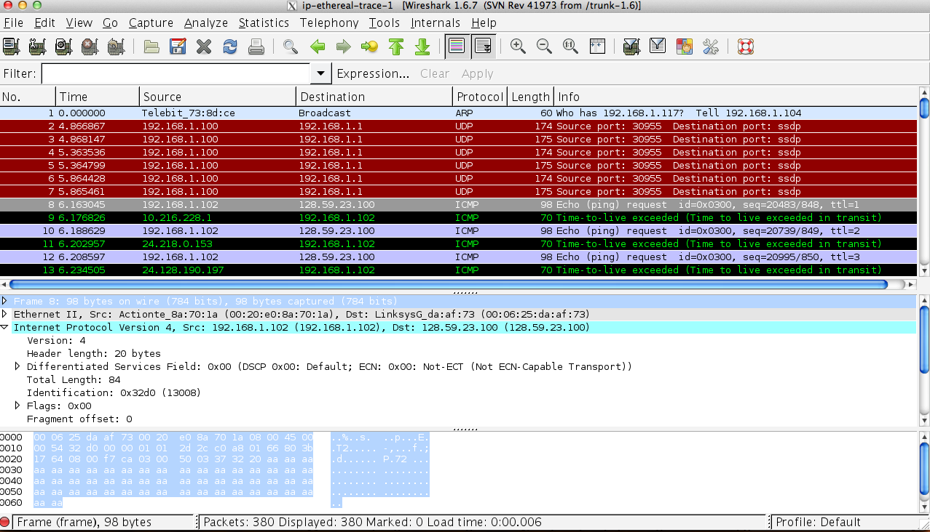
What is the IP address of your computer?
Source: 172.17.44.39

- Within the IP packet header, what is the value in the upper layer protocol field?
Header Length: 20 bytes

- How many bytes are in the IP header? How many bytes are in the payload of the IP datagram? Explain how you determined the number of payload bytes.
Total legth 50 – header lenth 20 = 36

- Has this IP datagram been fragmented? Explain how you determined whether or not the datagram has been fragmented.
No esta fragmentado ya que el tamano es de 1500 y como el total es de 56 no esta fragmentado
Next, sort the traced packets according to IP source address by clicking on the Source column header; a small downward pointing arrow should appear next to the word Source. If the arrow points up, click on the Source column header again. Select the first ICMP Echo Request message sent by your computer, and expand the Internet Protocol portion in the “details of selected packet header” window. In the “listing of captured packets” window, you should see all of the subsequent ICMP messages (perhaps with additional interspersed packets sent by other protocols running on your computer) below this first ICMP. Use the down arrow to move through the ICMP messages sent by your computer.

- Which fields in the IP datagram always change from one datagram to the next within this series of ICMP messages sent by your computer?

- Identificaciòn
- Suma de comprobación de la cabecera
- Source
- Desplazamiento del fragmento.
- Time to live
- Destino
- Tamaño total

- Which fields stay constant? Which of the fields must stay constant? Which fields must change? Why?
  - Tamano de cabecera
  - Protocolo
  - Version
  - Campo de servicio diferenciado
Which of the fields must stay constant?
- Protocolo
- Version
- Tamano de cabecera

El origen y el destino dado que se intercambian entre las solicitud y la respuesta.

- Describe the pattern you see in the values in the Identification field of the IP datagram

Los valores de identificación de cada paquete mientras llegan a uno de los routers varia ligeramente pero al cambiar a otro router la identificar identificaciòn varía aún más.

Next (with the packets still sorted by source address) find the series of ICMP TTL-exceeded replies sent to your computer by the nearest (first hop) router.

- What is the value in the Identification field and the TTL field?
Identificaciòn: 0x0000
Time to live: 56

- Do these values remain unchanged for all of the ICMP TTL-exceeded replies sent to your computer by the nearest (first hop) router? Why?
El ttl se mantiene igual dado que indica el límite de nodos por los que del paquete pasará antes de ser rechazado pero la identificaciòn cambia

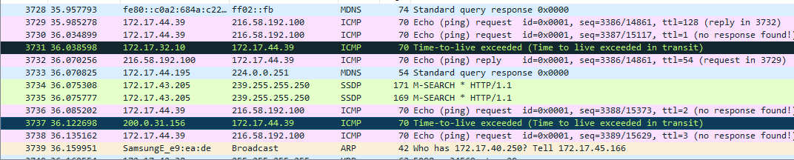
Fragmentation

Sort the packet listing according to time again by clicking on the Time column.

- Find the first ICMP Echo Request message that was sent by your computer after you changed the Packet Size in pingplotter to be 2000. Has that message been fragmented across more than one IP datagram? [Note: if you find your packet has not been fragmented, you should download the zip file http://gaia.cs.umass.edu/wireshark-labs/wireshark-traces.zip and extract the ip-ethereal-trace-1packet trace. If your computer has an Ethernet interface, a packet size of 2000 should cause fragmentation.]

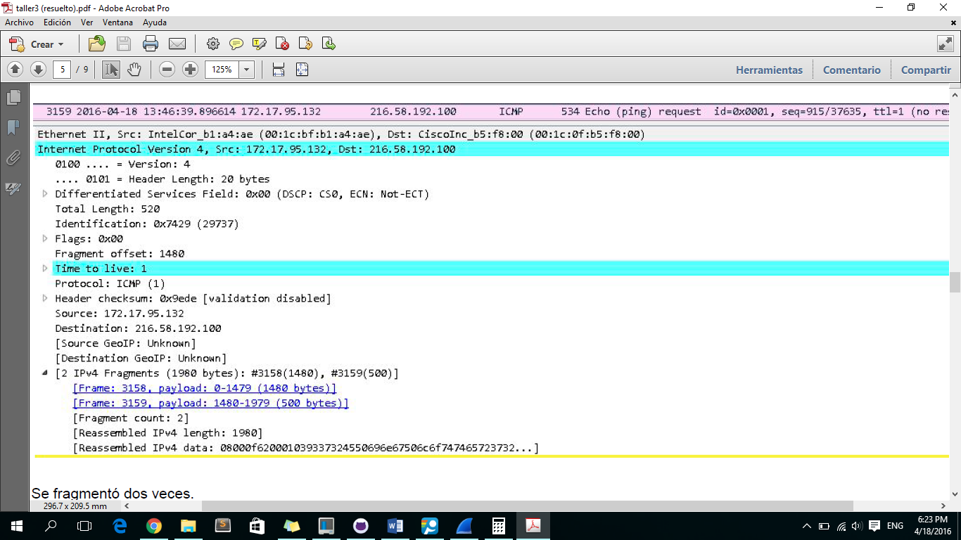
- `How long is this IP datagram?

What information in the IP header indicates whether this is the first fragment versus a latter fragment?
El valor de las flags
How long is this IP datagram?
1980 bytes
- Print out the second fragment of the fragmented IP datagram. What information in the IP header indicates that this is not the first datagram fragment? Are the more fragments? How can you tell?

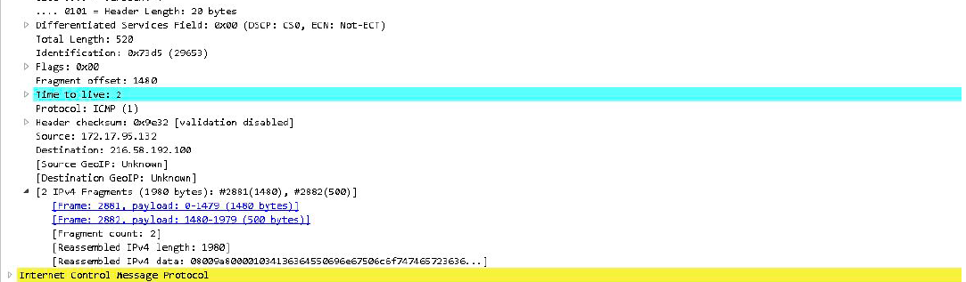

- What fields change in the IP header between the first and second fragment?
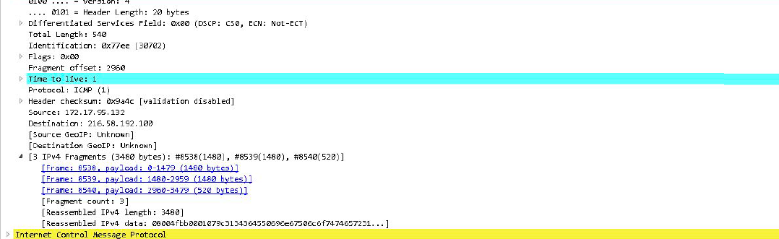

Now find the first ICMP Echo Request message that was sent by your computer after you changed the Packet Size in pingplotter to be 3500.

- How many fragments were created from the original datagram?
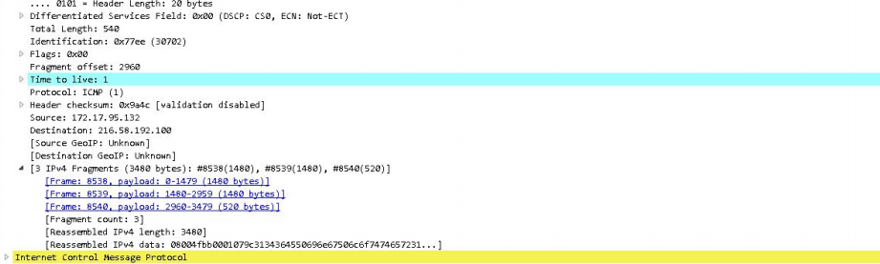
Genero 3 fragmentos

- What fields change in the IP header among the fragments?

La identificaciòn y el TLL

References to figures and sections are for the 6th edition of our text, Computer Networks, A Top-down Approach, 6th ed., J.F. Kurose and K.W. Ross, Addison-Wesley/Pearson, 2012.
Download the zip file http://gaia.cs.umass.edu/wireshark-labs/wireshark-traces.zip and extract the file ip-ethereal-trace-1. The traces in this zip file were collected by Wireshark running on one of the author’s computers, while performing the steps indicated in the Wireshark lab. Once you have downloaded the trace, you can load it into Wireshark and view the trace using the File pull down menu, choosing Open, and then selecting the ip-ethereal-trace-1 trace file.
The packets in the ip-ethereal-trace-1 trace file in http://gaia.cs.umass.edu/wireshark-labs/wireshark-traces.zip are all less that 1500 bytes. This is because the computer on which the trace was gathered has an Ethernet card that limits the length of the maximum IP packet to 1500 bytes (40 bytes of TCP/IP header data and 1460 bytes of upper-layer protocol payload). This 1500 byte value is the standard maximum length allowed by Ethernet. If your trace indicates a datagram longer 1500 bytes, and your computer is using an Ethernet connection, then Wireshark is reporting the wrong IP datagram length; it will likely also show only one large IP datagram rather than multiple smaller datagrams.. This inconsistency in reported lengths is due to the interaction between the Ethernet driver and the Wireshark software. We recommend that if you have this inconsistency, that you perform this lab using the ip-ethereal-trace-1 trace file.

